

Dated: <To>

**TO WHOM IT MAY CONCERN**

It is certified that Mr. <Name> S/o <fname> worked in Serina Engineering Company as a <Designation> from <From> to <To> at Disttellry Plant Muzaffargarh.

During his stay in our organization we found him hard working and having a good moral character. We have no objection on his doing work at any where.

We wish him best of luck for his success in his future life.

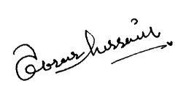

Ibrar Hussain General Manager.

